Beauty and Joy of Computing Unit 2 Assessment
Create a survey project that meets all of the following specifications:
- Collects data from the user by asking the user a specific question and gathering their response using the ask and answer blocks.
For example:
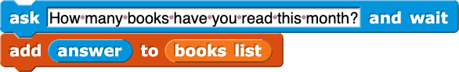
- Stores the collected data in a list. Put at least ten example responses into the list yourself.
- Processes the data to answer three research questions by using one or more of the following blocks:
  - keep
  - combine
  - the list-processing blocks you built in Lab 4 on Page 3:
    - maximum of list
    - minimum of list
    - sum of list
    - average of list
For example: If you asked “How many books have you read so far this month?” you could analyze the data to answer the following research questions:
  - What is the average number of books people have read so far this month?
  - What is the maximum number of books people have read so far this month?
  - How many people have read at least two books this month?

